FOOD SERVICE TIMES

MONDAY TO SATURDAY ~ 12pm – 8.30pm

SUNDAYS ~ 12pm – 4.30pm

BANK HOLIDAY MONDAY ~ 12pm – 5pm

2 High Street

Minster

Ramsgate

CT12 4BU

Tel: 01843 825707

Email: [thebellinnminster@outlook.com](mailto:thebellinnminster@outlook.com)

Website: <https://thebellinnminster.weebly.com>

Facebook: The Bell Inn Minster

****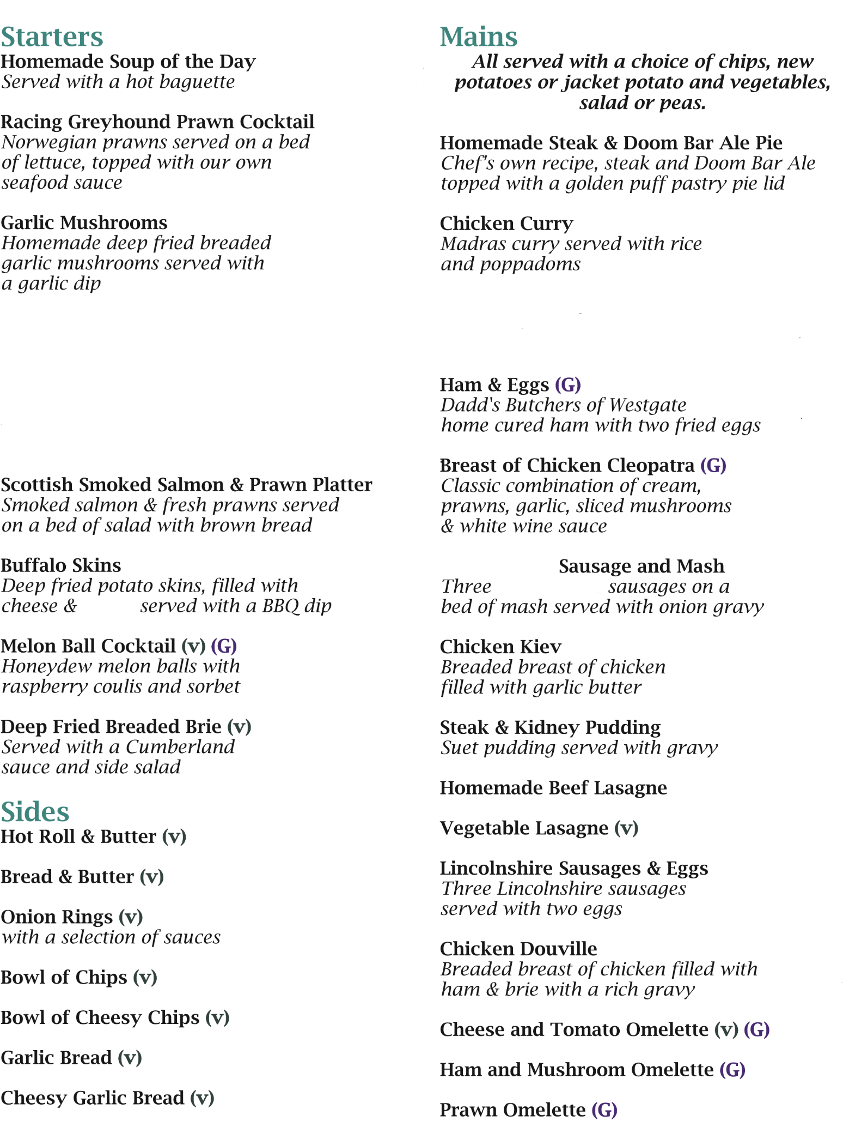

**Mains**

*All served with a choice of chips, new potatoes or mash and vegetables, Salad or peas.*

**Homemade Steak & Doom Bar Ale Pie**

*Chef`s own recipe, Steak and Doom Bar Ale*

*topped with a golden puff pastry pie lid* £11.95

**Steak & Kidney Pudding**

*Suet pudding served with gravy*£12.45

**Chicken Curry (G)**

*A choice of Madras or Korma curry served with rice*

*and poppadom’s*  £12.95

**Ham & Eggs (G)**

A.J Cliffe butchers of Minster

*home cured ham with two fried eggs* £10.95

**Cumberland Sausage and Mash**

*Three Cumberland sausages on a*

*bed of mash served with onion gravy*  £10.95

**Cumberland Sausages & Eggs**

*Three Cumberland sausages*

*served with two eggs £10.95*

**Chicken Kiev ~ Homemade**

*Breaded breast of chicken*

*filled with garlic butter £12.95*

***NEW Chicken Escalope***

*Breadcrumbed Breast of Chicken*

*With a Creamy Mushroom Sauce £12.95*

**Chicken Campana**

*Breaded Breast of Chicken*

*Filled with Mozzarella and Spinach*

*With a rich Tomato & Basil Sauce £12.95*

***Hunter’s Chicken***

*A breast of Chicken with Bacon, Cheese*

*and a BBQ Sauce. £13.45*

***NEW Liver & Bacon***

*Succulent Lamb`s Liver served with Onion`s and Mash £13.95*

***Vegetarian Sausage & Mash £10.95***

***Vegetarian Sausage & Eggs £10.95***

***Pasta Dishes***

*Served with Chips or Homemade Garlic Bread and Salad*

**Tomato & Cheese Pasta Bake** £11.25

*Served in a Tomato & Basil Sauce*

**Spaghetti Carbonara**

With Ham £11.25

With Ham and Prawns £11.75

**Beef Lasagne** £11.25

**Vegetable Lasagne (V)**  £11.25

The Bell Inn

**PLEASE ADVISE OUR STAFF OF ANY DIETARY NEEDS OR ALLERGIES**

**Starters**

**Sharing Platter for 2** £13.95

*Chicken Nuggets, Garlic Mushrooms, Onion Rings*

*Scampi, Garlic Bread & Salad Garnish*

**Homemade Soup of the Day**

*Served with hot petit pains* £6.45

**The Bell Inn’s Prawn Cocktail**

*Juicy Atlantic prawns served on a*

*bed of iceberg lettuce topped with our*

*own seafood sauce*  £8.95

**Breaded Garlic Mushrooms (V)**

Mushrooms, Breaded & deep fried

*served with a garlic mayo dip £8.95*

**Scottish Smoked Salmon and Prawn Platter**

*Smoked salmon & fresh prawns served*

*with a bed of salad and brown bread £8.95*

**Breaded Butterfly Prawns**

*Six Butterfly Prawns deep fried*

*And served with a sweet chilli sauce £8.95*

**Deep Fried Mozzarella (V)**

*Breaded mozzarella served*

*With a sweet chilli sauce*  £8.95

**Chicken Liver Pate (GF)**

Chicken Liver Pate with a hint of Scottish Whisky served with a side of Toast & a Red Currant Jelly

£8.95

**Sides**

**Hot Roll & Butter (V)** £2.75

**Onion Rings (V)**

**With a selection of sauces** £3.50

**Bowl of Chips (V)** £3.25

**Bowl of Cheesy Chips (V)** £3.50

**Garlic Bread (V)** £3.25

**Cheesy Garlic Bread (V)** £3.50

***Tomato and Mozzarella Bake***

Served with a tomato and basil sauce

***Cumberland***

***Cumberland***

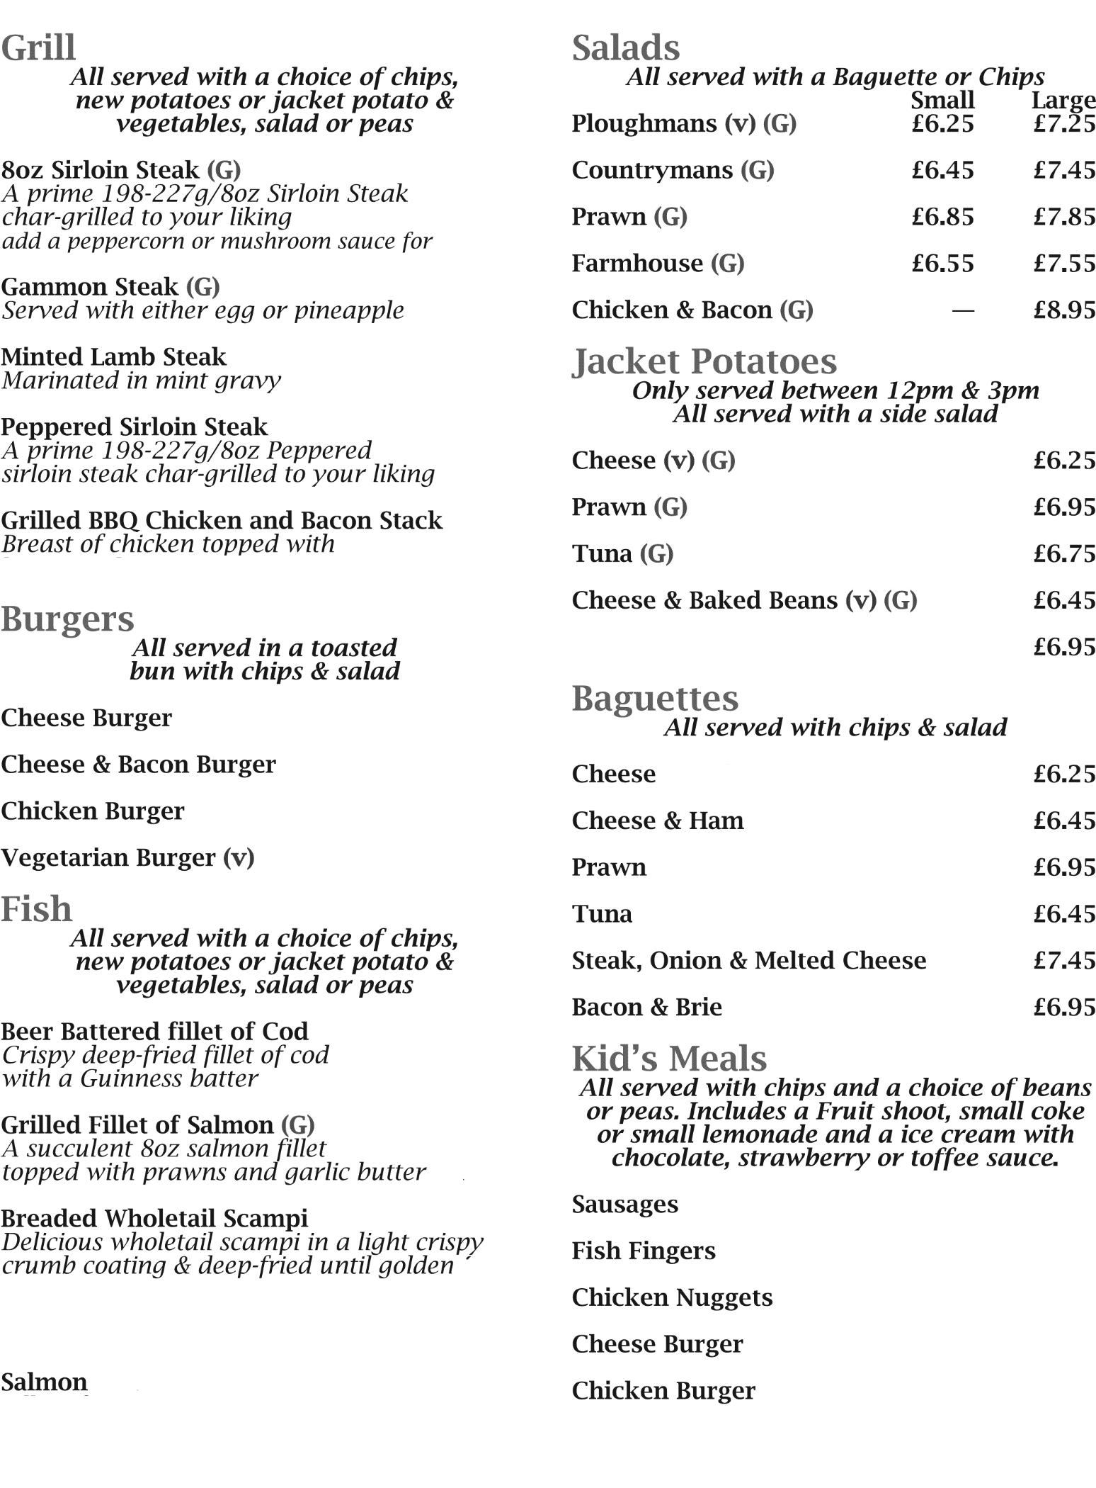

***Salads***

*All served with a Baguette or Chips*

**Ploughman’s**

*With Cheddar or Stilton**(V)(G) £10.45*

**Countryman’s (G)** *£10.45*

*With Ham*

**Farmhouse (G)** *£10.95*

With Cheddar & Ham

**Fisherman’s (G)** *£10.95*

*With Prawn & Tuna*

**Hot Chicken & Croutons** *£11.95*

***Jacket Potatoes*** *-only served between 12pm-3pm*

*All served with a side salad.*

**Cheese (V) (G)** £7.75

**Prawn (G)** £8.45

**Tuna (G)** £8.25

**Cheese & Baked Beans (V) (G)** £7.95

***Baguettes***

*All served with chips & salad*

**Cheese & Ham** £8.95

**Prawn** £8.95

**Tuna** £8.95

**Bacon & Sausage** £8.95

**Steak, Onion & Melted Cheese** £9.25

***Kid’s Meals***

*All served with chips and a choice of beans or peas.*

*Includes a Fruit shoot, small coke or small lemonade and an ice cream with chocolate, Strawberry or toffee sauce.*

**Sausages** *£9.45*

**Fish Fingers** *£9.45*

**Chicken Nuggets** *£9.45*

**Cheese Burger** *£9.45*

**Chicken Burger** *£9.45*

**Vegetarian Burger** *£9.45*

***PLEASE ADVISE OUR STAFF OF ANY***

***DIETARY NEEDS OR ALLERGIES***

***Grill***

*All served with a choice of chips, new potatoes and vegetables, salad or peas.*

**8oz Sirloin Steak (G)**

*A prime 198-227g / 8oz Sirloin Steak*

*Served with Mushrooms & Grilled Tomato*

*Cooked to your liking £17.95*

*add a peppercorn or mushroom sauce for £3.00*

**Gammon Steak(G***)*

*Served with either egg or pineapple £12.95*

***BBQ Rack of Ribs***

*A Rack of Ribs smothered in a BBQ sauce, Corn on the cob & Grilled Tomato £16.95*

**Burgers**

*All served in a toasted bun*

*with chips & salad.*

***The Bell Burger Plain*** *£12.95*

*Served with Cheddar Cheese, Bacon, Red Onion Chutney, Fried Egg*

***Chicken Burger***

*With lettuce and mayonnaise*£10.95

***Thai Vegetable Burger*** *(v)* £10.95

*With Sweet chilli sauce*

**Fish**

*All served with a choice of chips or new potatoes and vegetables, salad or peas.*

**Beer Battered fillet of Cod**  *£11.95*

*Crispy deep-fried fillet of cod*

*with a Fosters Lager batter*

**Grilled Fillet of Salmon (G)** *£12.95*

*A succulent 8oz salmon fillet*

*topped with prawns and*

*garlic butter*

**Breaded Wholetail Scampi** *£11.95*

*Delicious wholetail scampi in a*

*light crispy crumb coating &*

*deep fried until golden*

The Bell Inn

**Salmon St Clements**

*Fillet of Salmon with an orange and Lemon sauce*

***Plaice Goujons***

*Deep fried breaded plaice goujons with a tartar sauce*



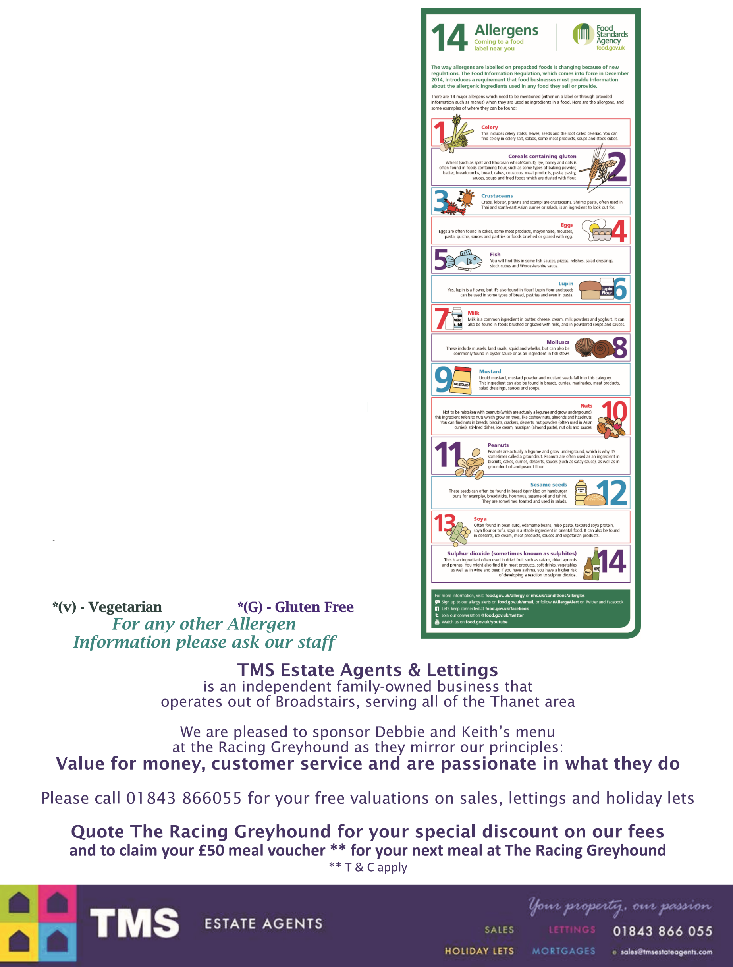

The Bell Inn

**Coffee**

White coffee £2.25

Black Coffee £2.10

Decaffeinated £2.10

Cappuccino £2.60

Latté £2.60

Mocha £2.80

Double Espresso £2.50

Hot Chocolate £2.35

Hot Chocolate £2.75

With cream

Tea £2.10

**Liqueur Coffee**

Irish £4.95

French £4.95

Calypso £4.95

Jamaican £4.95

Baileys £4.95

Coffee

Liqueur Coffee